**User’s Manual**

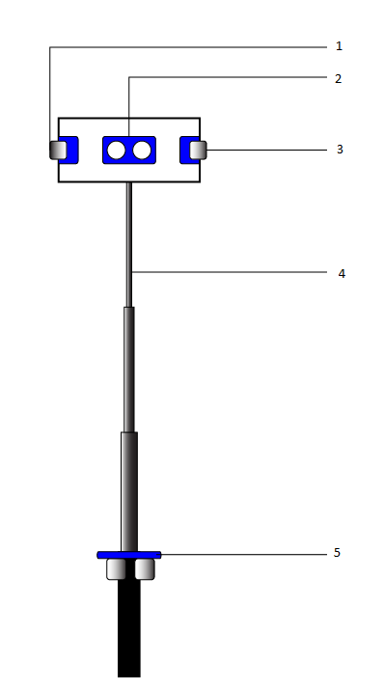

1: Ultrasonic sensor (Right)

2: Ultrasonic sensor (Front)

3: Ultrasonic sensor (Left)

4: Resizable Stick

5: Ultrasonic sensor (Pothole detection)

Step1: Adjust the settings to add the contacts for first time setup.

Step2: Hold the stick as per the height of user.

Step3: As soon as stick is connected to phone, the app will launch automatically.

Step4: The stick will then calibrate the threshold according to the height of user.

Step5: As soon as the distance is calculated, the correct user direction will be given to the user.

Step6: The user can double tap on the screen to enable the navigation, speak the destination and the navigation will start.

Step7: Right swipe on the blue area, to open the gesture recognition.